**EXPERIMENT -16**

**AIM:** Write a program to implement selection sort on an array.

**ALGORITHM:**

**SOURCE CODE:**

#include <iostream>

using namespace std;

void printArray(int array[], int size) {

for (int i = 0; i < size; i++) {

cout << array[i] << " "; }

cout << endl;}

void swap(int *a, int *b) {

int temp = *a;

*a = *b;

*b = temp;

}

void selectionSort(int array[], int size) {

for (int step = 0; step < size - 1; step++) {

int min_idx = step;

for (int i = step + 1; i < size; i++) {

if (array[i] < array[min_idx])

min_idx = i;

}

swap(&array[min_idx], &array[step]); }

}

int main() {

int n;

cout << "Enter the size of the array : ";

cin >> n;

int arr[n];

cout << "Enter your elements : ";

for (int i=0; i<n; i++) {

cin >> arr[i];

}

selectionSort(arr,n);

cout << "Sorted array:\n";

printArray(arr, n);}

**EXPERIMENT -16**

**AIM:** Write a program to implement selection sort on an array.

**OUTPUT:**

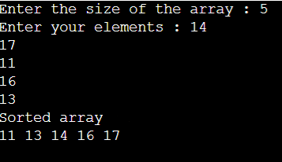

**EXPERIMENT -17**

**AIM:** Write a program to implement bubble sort on an array.

**ALGORITHM:**

**SOURCE CODE:**

#include <bits/stdc++.h>

using namespace std;

void bubble_sort(int arr[], int n) {

for (int i=0; i<n-1; i++) {

for (int j=0; j<n-1-i; j++) {

if (arr[j] > arr[j+1]) {

int temp = arr[j+1];

arr[j+1] = arr[j];

arr[j] = temp;}

}

}

}

int main() {

int n;

cout << "Enter the size of the array : ";

cin >> n;

int arr[n];

cout << "Enter your elements : ";

for (int i=0; i<n; i++) {

cin >> arr[i];

}

bubble_sort(arr, n);

cout << "Sorted array : ";

for (int i=0; i<n; i++) {

cout << arr[i] << " ";

}

}

**EXPERIMENT -17**

**AIM:** Write a program to implement bubble sort on an array.

**OUTPUT:**

